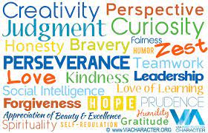

Neil Armstrong becoming first person to walk on The Moon- Ruby

In 5/6 C we have been exploring amazing feats in History. We then had to think critically about how these people would have used their Character Strengths to help them achieve success.

Herbert Nitsch deepest free dive - Samuel

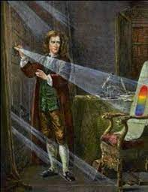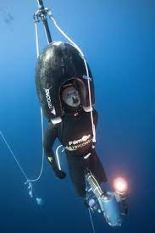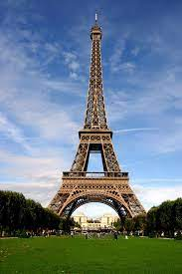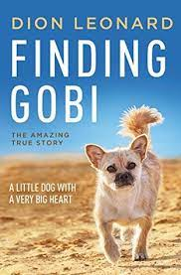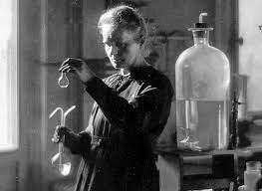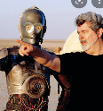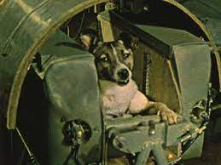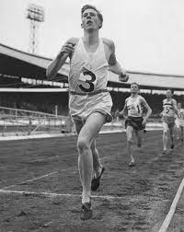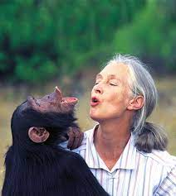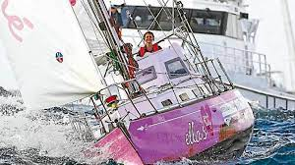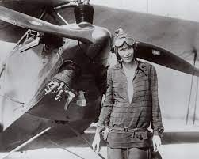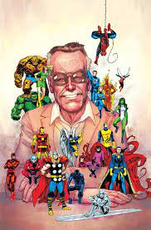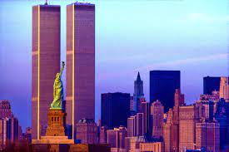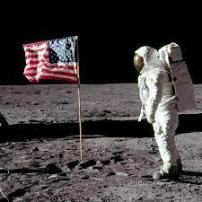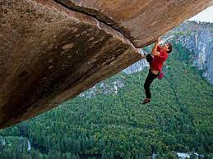

George Lucas becoming highest-grossing director- Caleb

Jessica Watson the youngest person to sail solo around the world- Chloe

The construction of The Eiffel Tower- Jasper

Dion Leonard and Gobi the dog running ultra -marathons- Isabella

Shaun Burgoyne becoming first Indigenous person to play 400 games- Harper

Construction of Burj Khalifa- Luca

Mission to help get First dog in space- Riley

Roger Bannister running the first sub-4-minute mile- Bella

Jane Goodall’s work in animal conservation-Asha

Construction of

The Twin Towers- Austin

Isaac Newton’s discovery on the spectrum of light-Orlando

Amelia Earhart becoming first woman to fly across The Atlantic- Alexandra

Stan Lee for starting a Comic Revolution- Cody

Alex Honnold the first ‘Free Solo’ climb of El Capitan-

Oliver and Jonathan

Marie Curie’s discovery of Radium

Eva, Ekta & Elaine